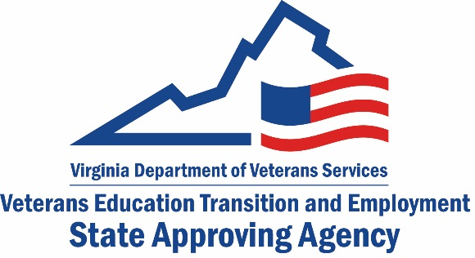
Request for an Application to Provide Training to Veterans and Other Eligible Persons
Note: Federal agencies must be approved directly by the U.S. Department of Veterans Affairs. If your facility is a federal agency, please do not fill out this form. Please contact us at saa@dvs.virginia.gov for the DVA point of contact.

Date of Request:
Facility Name:
Address:
City:
State: |  |  |  | Zip Code:
Contact Person:
Phone Number:
Fax Number:
Email :
- Is your facility an apprenticeship or on-the-job training (OJT) establishment?
No | Yes, OJT  Yes, registered apprenticeship  Yes, non-registered apprenticeship
If you checked any of the “yes” boxes above, you are done with this form. Please email it to saa@dvs.virginia.gov
- Do you own (not just offer) a licensure or certification test?
No | Yes, governmental  Yes, non-governmental
If you checked any of the “yes” boxes above, you are done with this form. Please email it to saa@dvs.virginia.gov
- Is your facility an accredited high school?
No | Yes
If you checked “yes” above, you are done with this form. Please email it to saa@dvs.virginia.gov

- Is your school accredited by an accrediting agency recognized by the U.S. Department of Education (http://www.chea.org/search/search.asp)?
No |  | Yes
- If you answered “yes” to #4, please list the agency:
- Is your school:
For profit |  |  | Private non-profit |  | Public
- Does your school offer (check all that apply):
Undergraduate degrees |  |  | Graduate degrees |  | Certificates/diplomas
- Has your school been in operation in the Commonwealth of Virginia for at least two years?
No |  | Yes
- Does your school have a Certificate to Operate (CTO) from the State Council of Higher Education for Virginia (SCHEV)? (Contact SCHEV at 804-225-3093)
No |  | Yes
- If you answered “no” to #9, does your school have an exemption?
No |  |  | Yes (enclose a copy of your exemption letter with this form) |  | N/A (explain):
- Does your school fall under the jurisdiction of any of the State Agencies listed on the following page?
No |  | Yes (which one):
Please email this form to saa@dvs.virginia.gov
Saa Official use Only
Date form received:
Type of application sent:
Date application sent:
Remarks:

Note: All programs of education must go through the State Council of Higher Education for Virginia (SCHEV), unless it falls under one of the categories below:

Program/School Type | Approving State Agency
Apprenticeships | Virginia Department of Labor and Industry (DOLI)
CDL and Professional Driver Training | Virginia Department of Motor Vehicles
Certified Nursing Assistant | Virginia Board of Nursing
Cosmetology & Barbering (Non Title-IV) | Board for Barbers & Cosmetology – under Virginia Department of Professional & Occupational Regulation (DPOR)
Cosmetology & Barbering (Title-IV eligible) | SCHEV and Virginia Department of Professional & Occupational Regulation (DPOR)
Electrical, Plumbing, HVAC, Gas fitting | Virginia Board of Contractors –under Virginia Department of Professional & Occupational Regulation (DPOR)
EMT & Paramedic | Virginia Department of Health
Esthetics (Non-Title IV) | Board for Barbers & Cosmetology – under Virginia Department of Professional & Occupational Regulation (DPOR)
Esthetics (Title-IV eligible) | SCHEV and Virginia Department of Professional & Occupational Regulation (DPOR)
Flight | Federal Aviation Administration
Fire Fighting | Virginia Department of Fire Programs
Insurance | State Corporation Commission
Maritime | U.S. Coast Guard
Massage Therapy | SCHEV
Medication Aide | Virginia Board of Nursing
Nurse Aide | Virginia Board of Nursing
Personal Care Aide | Virginia Department of Medical Assistance Services
Pharmacy & Pharmacy Tech | Virginia Board of Pharmacy
Phlebotomy | SCHEV
Private Security, Law Enforcement, Tow Truck Drivers | Virginia Department of Criminal Justice Services
Real Estate | Board of Real Estate – under Virginia Department of Professional & Occupational Regulation (DPOR)

