Southwest Virginia Veterans Cemetery
5550 Bagging Plant Road
Dublin, Virginia 24084
Office 540-674-6893 Fax 540-674-6897
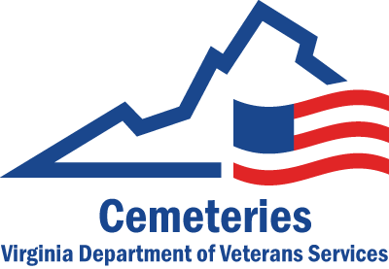 PRE APPLICATION FOR INTERMENT

Name of Veteran _____________________________________________________________________________
(Last) (First) (Full Middle) (Junior/Senior)

Social Security Number _________________________________________________________________________

Military Service Number _____________________Branch of Service _____________Highest Rank_____________

Dates of Military Service_________________________________________________________________________

War Service ( ) WWI ( ) WW II ( ) Korea ( ) Vietnam ( ) Persian Gulf ( ) Iraq

Date and Place of Birth__________________________________________________________________________

Current Address_______________________________________________________________________________

Spouse OR Next of Kin ________________________________Relationship_______________________________

Social Security Number________________________________ Date of Birth_______________________________

Address ______________________________________________________________________________________

Telephone Numbers: Veteran___________________________ Next of Kin_______________________________

Email addresses: Veteran_______________________________ Next of Kin _______________________________

Would you like to receive our quarterly Newsletter via email? ( ) Yes ( ) No

Please check one of the following concerning your choice of Ground Interment:
- Upright granite marker/In pre-installed double depth concrete lawn crypt section (no charge) ____________
- Upright white marble marker/Purchasing Outer Burial Container form the Department of Veterans Services at cost (presently $400.00) ___________ ( oversized presently $475.00)________________
- Upright white marble marker/Purchasing vault from funeral home_____________________

If Cremation: Columbarium Niche_________ Ground Interment with flat gray granite marker _______________

I hereby apply for determination of eligibility for interment at the Southwest Virginia Veterans Cemetery

Veteran’s or Next of Kin’s Signature: ___________________________________ Date________________________

- Enclosed LEGIBLE COPIES of your discharge papers indicating dates of service, branch of service, type of discharge and highest rank held ( normally this is on a DD-214 and or Form 53 )
- Enclosed LEGIBLE COPY of marriage license, if applicable
- This application is NOT a RESERVATION of a gravesite. However, a gravesite shall be assigned once a death has occurred and eligibility has been confirmed.
- How did you hear about us?

A Pre-Application determination of eligibility does not guarantee burial in a specific State cemetery. Burial in a specific State cemetery will be scheduled at the time of need.

