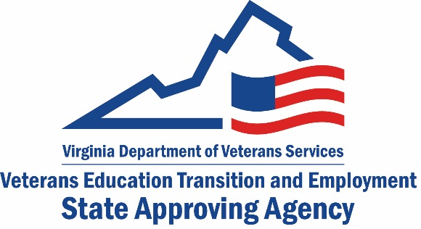
Request for Medical Residency, Fellowship or Internship
Application to Provide Training to Veterans and Other Eligible Persons
Note: Federal agencies must be approved directly by the U.S. Department of Veterans Affairs. If your facility is a federal agency, please do not fill out this form. Please contact us at saa@dvs.virginia.gov for the DVA point of contact.

Date of Request:
Facility Name:
Address:
City:
State: |  | Zip Code:
Contact Person:
Phone Number:
Fax Number:
Email :
- Is your residency or fellowship accredited?
No | Yes
If you checked “No” above, you are done with this form. Please email it to saa@dvs.virginia.gov
- Which accreditor has approved your program?
Accreditation Council for Graduate Medical Education

American Osteopathic Association

Commission on Dental Accreditation of the American Dental Association

Council on Podiatry Education of the American Podiatry Association

Other

If you checked “Other” above, you are done with this form. Please email it to saa@dvs.virginia.gov
Continue to next page

- Does your program lead to a certification by one of the following:
An appropriate Specialty or Subspecialty Board
American Osteopathic Association

American Dental Association

- If you checked Specialty or Subspecialty Board, indicate the Specialty:
__ __________________________________
Please email this form to saa@dvs.virginia.gov
Saa Official use Only
Date form received:
Type of application sent:
Date application sent:
Remarks:

Note: All programs of education must go through the State Council of Higher Education for Virginia (SCHEV), unless it falls under one of the categories below:

Program/School Type | Approving State Agency
Apprenticeships | Virginia Department of Labor and Industry (DOLI)
CDL and Professional Driver Training | Virginia Department of Motor Vehicles
Certified Nursing Assistant | Virginia Board of Nursing
Cosmetology & Barbering (Title-IV eligible) | SCHEV, Virginia Department of Professional & Occupational Regulation (DPOR), and accredited by an agency recognized by USDOE
Cosmetology & Barbering (Non-Title IV) | Virginia Department of Professional & Occupational Regulation (DPOR)
Electrical, Plumbing, HVAC, Gas Fitting | Virginia Board of Contractors –under Virginia Department of Professional & Occupational Regulation (DPOR)
EMT & Paramedic | Virginia Department of Health
Esthetics (Non-Title IV) | Board for Barbers & Cosmetology – under Virginia Department of Professional & Occupational Regulation (DPOR)
Esthetics (Title-IV eligible) | SCHEV and Virginia Department of Professional & Occupational Regulation (DPOR)
Fire Fighter | Virginia Department of Fire
Flight | Federal Aviation Administration
Private High Schools (Accredited) | Virginia Council for Private Education vcpe.org
Insurance | State Corporation Commission
Maritime | U.S. Coast Guard
Massage Therapy | SCHEV
Medication Aide | Virginia Board of Nursing
Nurse Aide | Virginia Board of Nursing
Personal Care Aide | Virginia Department of Medical Assistance Services
Pharmacy & Pharmacy Tech | Virginia Board of Pharmacy
Phlebotomy | SCHEV
Private Security, Law Enforcement, Tow Truck Drivers | Virginia Department of Criminal Justice Services
Real Estate | Board of Real Estate – under Virginia Department of Professional & Occupational Regulation (DPOR)

